Jonathan G. Foster Farm & Historic Ceremonial Site
– West Side Area
Formerly Canonchet Brook Site 10
Analysis by Mary Gage
Photos by Steve DiMarzo Jr. & James Gage
Copyright © 2017. All Rights Reserved.

Canonchet Brook Sites 8, 9, and 10 were originally designated based upon a very preliminary survey of the property by Steve DiMarzo and Todd Carden. Since the original reports were issued in 2014, Steve DiMarzo has done additional documentation, Rick Prescott, Hopkinton Historical Association has researched the deeds and genealogy of the area, and James Gage & Mary Gage conducted a field trip in October 2016 to better access the sites. All of this new information has required a reorganization of the reports and site designations.
Sites 8, 9, and 10 are all within the confines of the 50 acre Jonathan G. Foster Farm and are part of a historic Native American ceremonial site which was contemporary with the farming operation. All of the structures belong to a single site rather than three separate sites. Within this single site, four separate areas or sub-sites are discernable: East Side, West Side, Central, and South Side.
The Jonathan G. Foster Farm is one of three Foster farms discussed in the book Land of a Thousand Cairns: Revival of Old-Style Ceremonies (2017) by Mary Gage and James Gage. The book covers land use history, ownership, genealogy, and a detailed analysis of the stone structures. The reader is directed to that book for a more detailed description. What follows in this report is a basic summary of the pertinent facts. The book puts forth the theory that the three generations of Fosters who lived along Lawton Foster Road, Hopkinton, RI (Jonathan was the 2nd generation) were Native Americans who adopted the outward appearances of white culture while at the same time continued traditional spiritual practices and ceremonies.
Only a small number of the estimated 250 to 300 structures on the 50 acres have been documented.

Chronology and Ownership of 50 Acre Lot

17xx – 1801 Caleb Church *Property in state receivership from 1791 to 1801
1801 Caleb Church to John Cottrell $300 (Hopkinton Land Records bk.5 pg.422)
1801 John Cottrell obtained mortgage from Matthew Stillman $318 [included interest] (bk.5 pg.423)
Default on mortgage (not recorded)
1806 Matthew Stillman to Martin Brightman $320 (bk.6 pg.162)
1814 Martin Brightman to his nephews Thomas Brightman and Joseph Brightman $500 (bk.6 pg.474) *The price increase suggests Martin made improvements to the land which may have included a small house and clearing of pasture land.
1814-1816 Joseph Brightman, his wife Patience, and daughter Martha lived on the property
1816 Joseph died
1818 Patience married Jonathan G. Foster, Thomas Brightman sold his half interest in the farm to Patience for $250 (bk.7 pg.141)
After 1818 Jonathan Foster built a house with a double cellar, large barn, and sawmill. The remains of all three are present on the property. Sawmill was likely built in the 1830s and operated through at least 1870. It was transferred to his son Lawton Foster circa 1868.
1869 Jonathan Foster died.
1869-1888 farm owned and operated by Jonathan Foster’s daughter Samantha Clarke (widow). (1870 map, Hopkinton Tax Books)
1888 Samantha Clarke died.
1889-c.1900 farm owned by Samantha’s daughter Susan J. Spencer. (1895 Map)
c.1900 Property to sold the Hosxie family who owned a nearby farm.

Land Usage (based upon Joseph Brightman [1816] and Jonathan Foster [1869] probate records)

Small scale sheep farming (flock up to 10 sheep)
1 to 3 diary cows
1 pig
Crops: Corn, potatoes, rye
Orchard
Hay – Unclear if the farm had hay fields or not (hay may have come from rented fields elsewhere)
Timber harvesting & sawmill

NOTE: STRUCTURE #s

Steve DiMarzo explored this site on several different occasions. On two of the occasions the numbers were started at “1” which has caused some confusion. The structures documented during these individual trips ended up in different sub-sites causing additional problems. By the time the issue was discovered it was too late to renumber everything. Where two of same # occur in a given sub-site one was renumbered with the addition of an “A” (ex. #13 became #13A) The Gages October 2016 trip designated structures as A## to avoid any further confusion.
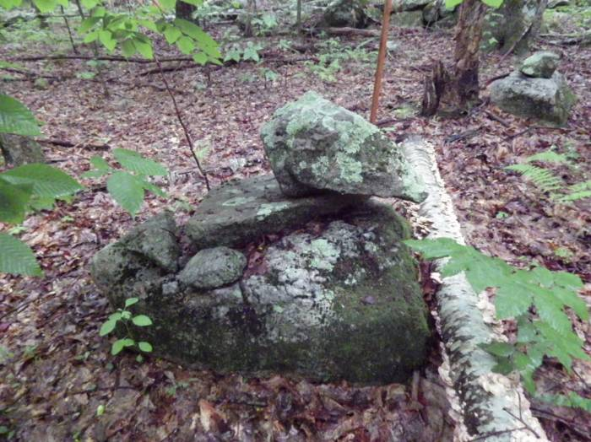
#1/#A3 Five Stones on top of a boulder

A slab was placed on top of the base stone. On top of the slab a chunky stone with a pointed end was placed with the pointed end overhanging the slab. Next to the chunky stone was a small stone on top of the slab. Directly on the base stone two medium sized stones were placed next to the slab.

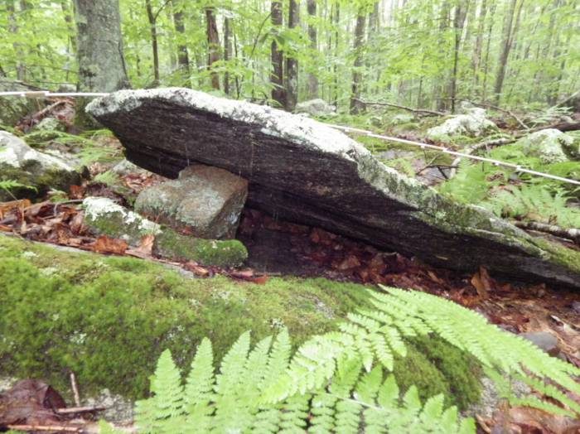
#2 Propped Slab

Among a rocky area a large thin stone slab was propped up. A slanted base stone was chosen, a small thin slab was placed on it, next a taller chunky stone. These two stones are the support stones. On top a large wide thin stone slab was laid. This is not a natural formation, it is man-made but made to blend in with its surroundings.

Propped slab: 3’ Wide

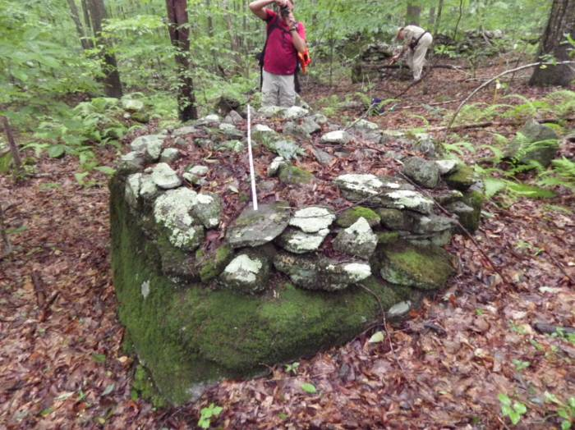
#3 Low vertical walled with fill on top of a flat topped boulder

Cairn has a square shape it conforms to the shape of the base stone
Base stone: 6’ W, with a square shape
Stone sizes: large, medium

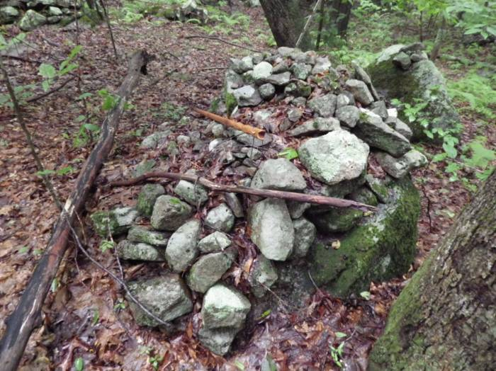
#4 Open-End / Closed-End on top of a gently sloping boulder

Base stone: 3’ H
Cairn: 1’ H
Stone sizes: Large, medium, small
Large stones in vertical wall and medium & small stones inside

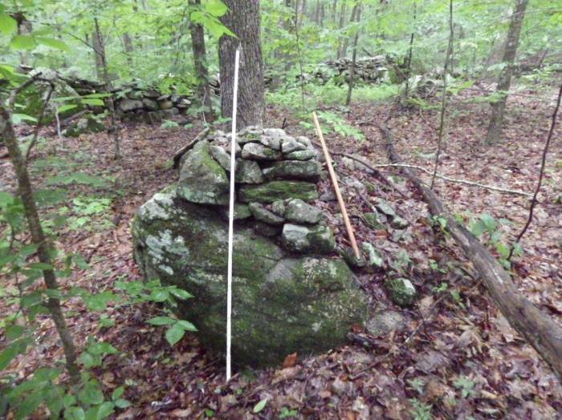

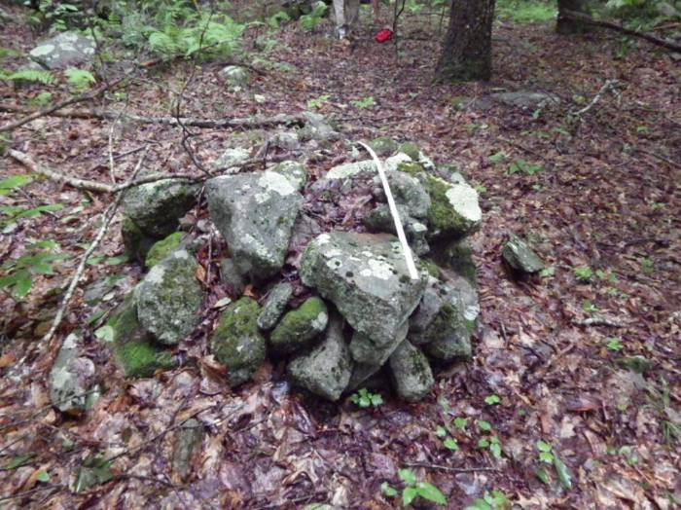
#5 On ground low mound

Cairn: 6’ W
Stone sizes: Large, medium, small

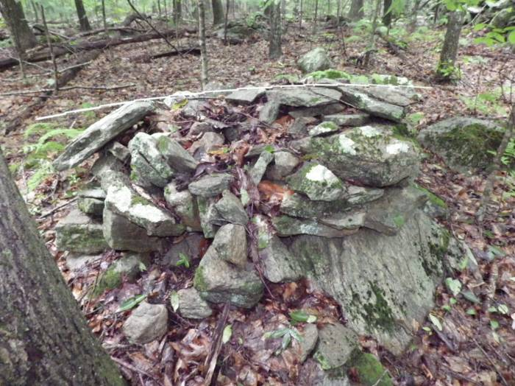
#6 Vertical Wall with fill attached to a boulder and on top of boulder (same boulder)

The cairn was built on top of the base boulder raising the height of it overall. The cairn continues along the side and back of the boulder where it was attached to it. It has an elongated shape.

Cairn: 5’ L x 3’ W
Stone sizes: Large, medium, small
Large stones in vertical wall and medium & small stones inside
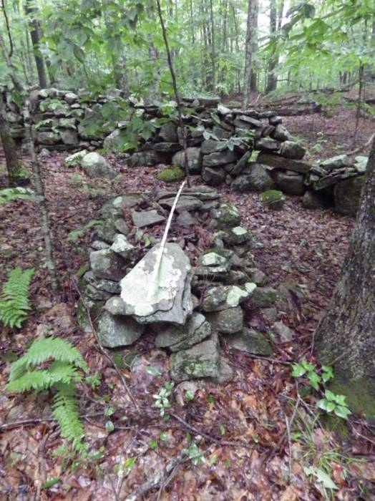
Feature: Large flat thin stone slab on top of one end

(right) large flat thin slab on top

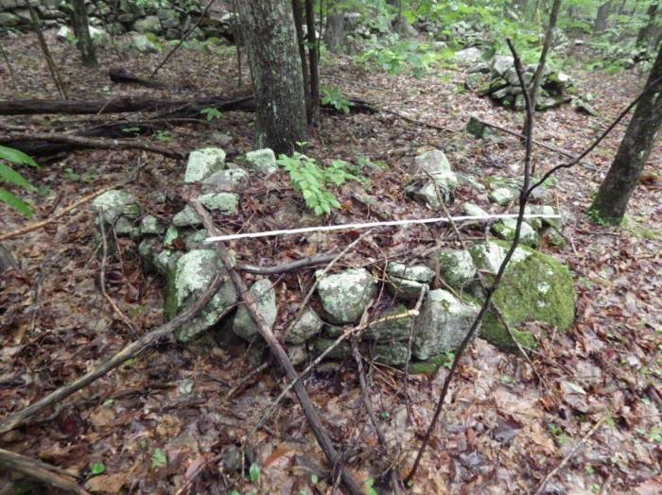
#7 Vertical walled with fill attached to a boulder

This cairn has the same height as the boulder it is attached to.

Cairn: 6’ W
Stone sizes: Large, medium, small
Large stones in vertical wall and medium & small stones inside

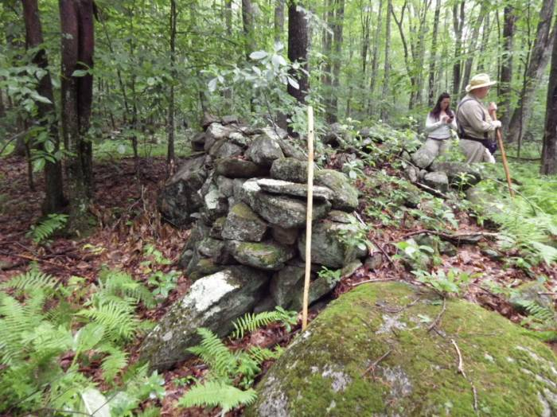
#8 Open-End / Closed-End cairn

Cairn was attached and built on top of three boulders on one side. Opposite side was built on the ground. Its backside slants downward and is open.

Cairn: 7’ L x 3’ H
Stone sizes: Large, medium
Large stones in vertical wall and medium stones inside

Note: The #9 was not used with this site

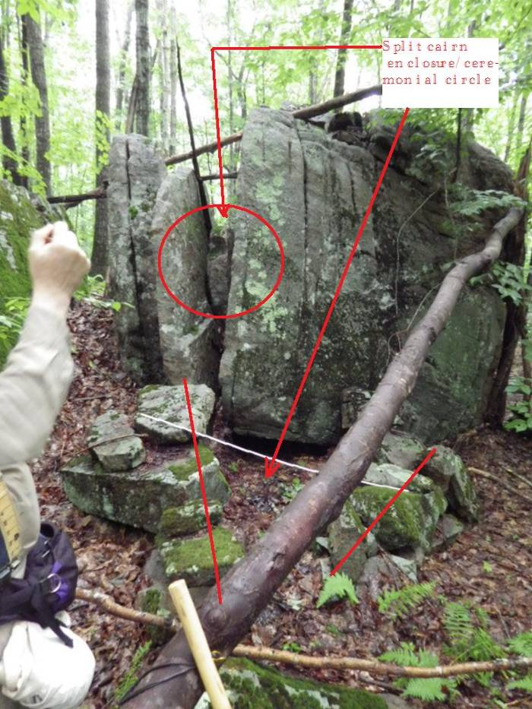
#10 Enclosure attached to a split stone outcrop
Split outcrop has a natural slab wedged inside split creating a natural split stone cairn. The natural structure was converted to a split stone cairn spirit portal when the Native Americans built a one person enclosure integrating the split stone feature into it. This type of set up has been found at other Rhode Island sites. For example see West Greenwich Carr Pond Site 8 structure #5.
Enclosure has low walls and a narrow entry. Its back wall is the split outcrop. Split is open to interior of enclosure.

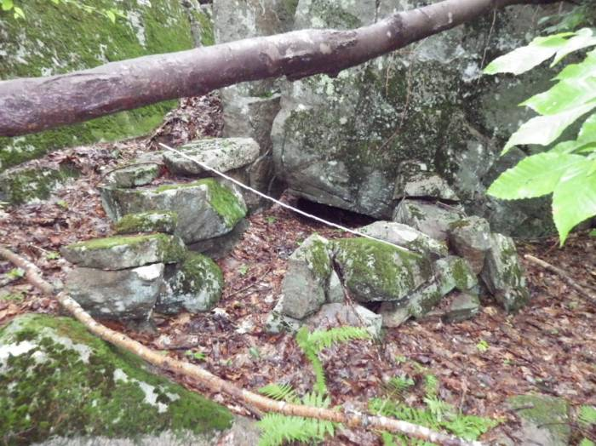
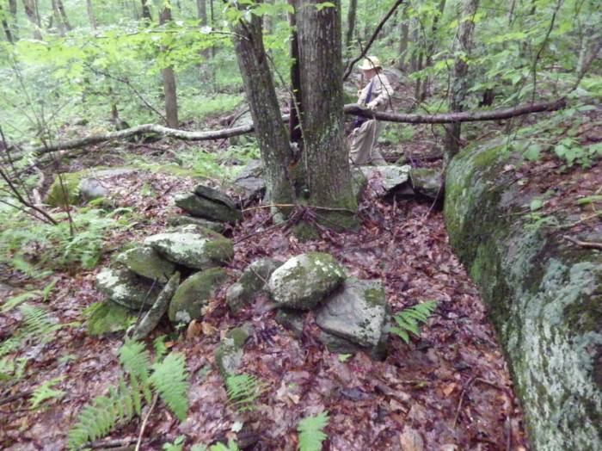
#11 Enclosure attached to an outcrop

The enclosure has a square shape with approximately 2 foot high walls. Its interior is 6 feet across. The narrow entry is next to the outcrop. Inside a large tree has grown it is intrusive to the enclosure.
Size: 6’ W x 2’ H
Shape: Square

The two enclosures according to Steve are approximately 150 feet apart.

Note: “AXX” designate structures documented by the Gages during their October 2016 trip.

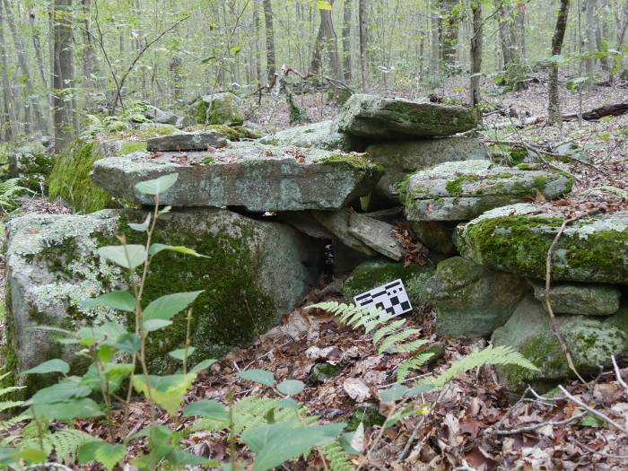
A1 – Niche

Niche interior 6” W x 10” H

The niche was built between a boulder and a stone wall. It is located along the inside edge of the farm road leading to the house and the barn. The roof of the niche is formed by thin shingle like stones which overlap each other. Above the shingle stones is a large flat stone slab that projects over the edge of the boulder. It is leveled on the backside by two shim stones. This stone slab serves as a counter balance for one of the shingle stones.
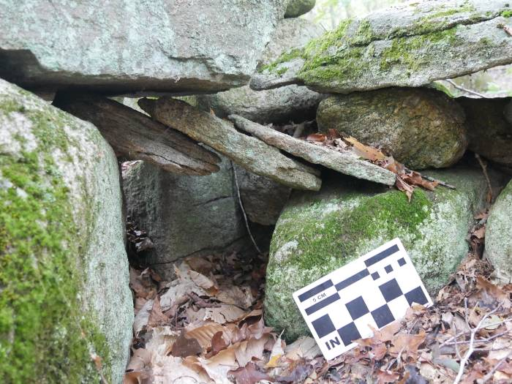

Thin shingle likes stone form roof of niche. One on far left is counter-balanced by the large stone slab above

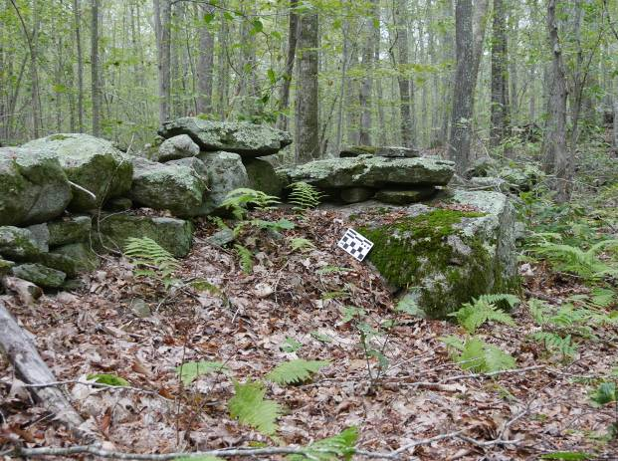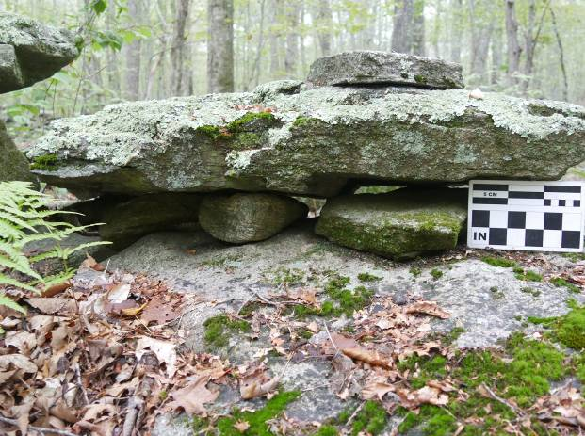

Opposite (back) side of niche
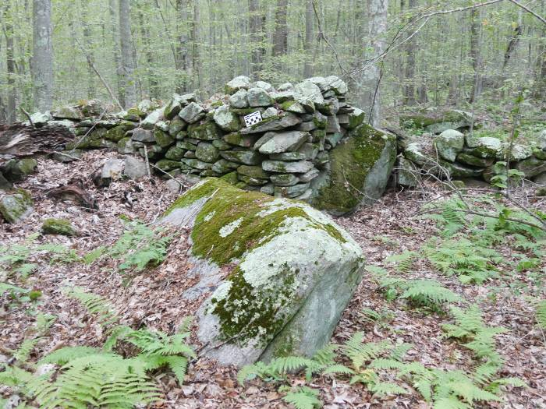
A2 – Triangular vertical walled cairn on boulder attached to stone wall

3’ H x 3’ W x 7’ L
Stone sizes: Large, medium, small
Interior is filled with stones 6” or less in length

A large boulder is inline with a stone wall on the west side of the farm road. The cairn was built against/on the sloping side of the boulder and merges with the stone wall on one end. It is near the “T” junction of two stone walls. On the opposite junction is a triangular corner wall cairn A17.
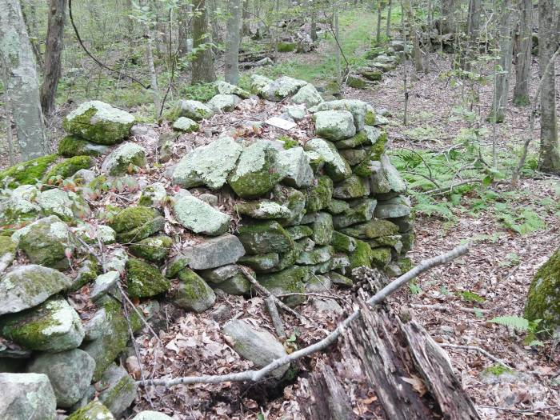

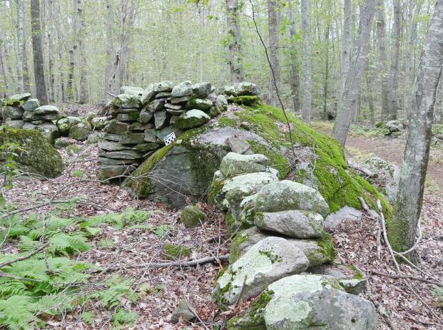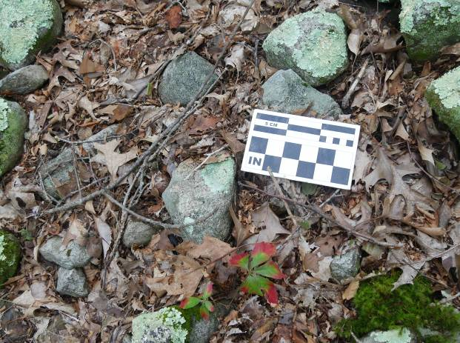

Interior stone fill 6” or less in length
Note A3 is the same as #1

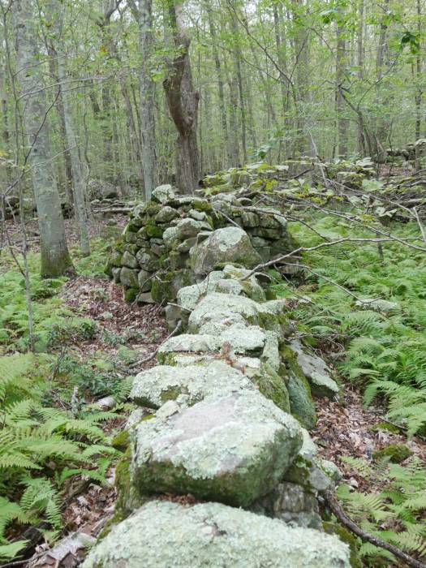
A4 – Oval vertical wall cairn integrated into stone wall

2 ½’ H x 4 ½” L

This oval shape cairn bulges out on both sides of the stone wall. It is filled predominately by small stones 6 inches or less in length. The stones used in the vertical wall cairn are generally smaller than those used in the stone wall itself.

A4 (continued)

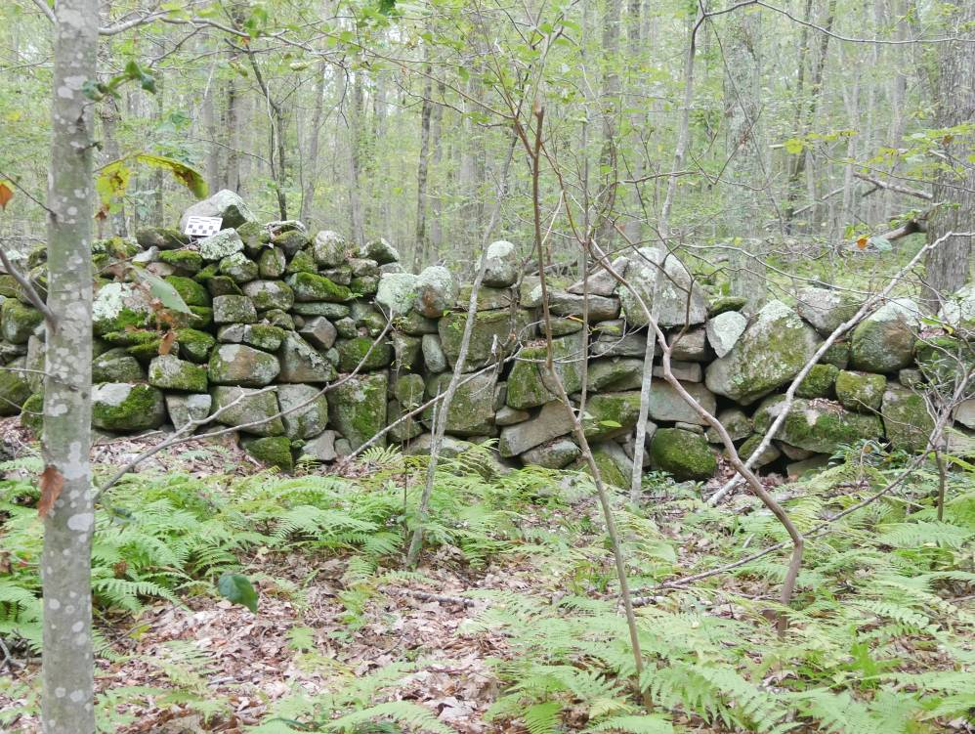
Cairn
Stone wall

Note difference in the size of stones used for the cairn and stone wall

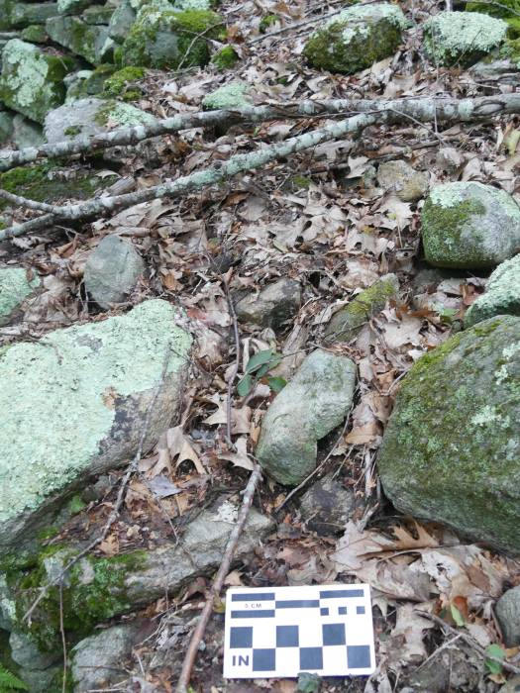

Small stones fill the interior of the cairn
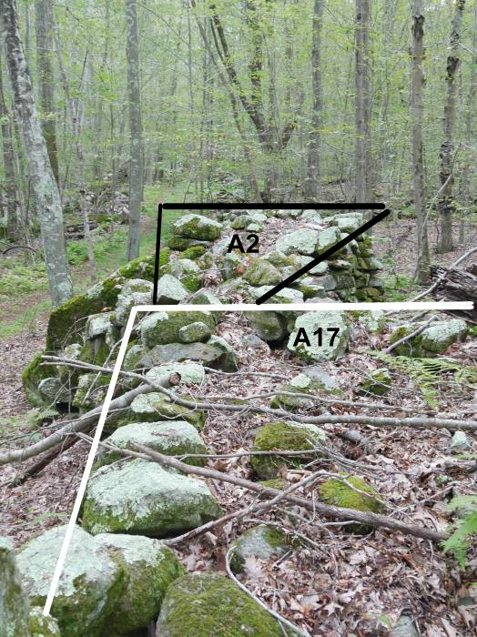
A17 Triangular corner wall cairn

A2 is seen at the opposite wall junction from A17

Noted in passing

A19 Enclosure

This enclosure was found by the authors. It has low walls, a square shape, an entry and was attached to a farm stonewall. It is large, the size of small paddock (33 feet wide x 33 feet long). But the problem is it’s located in a rocky wetlands area southwest of the other two enclosures and is not conducive to farm animals.

No photo

Serpentine Wall Entrance

A low serpentine wall with entrance in the middle extends from between two parallel pasture stones. It has several associated features. This is a ceremonial structure. A detailed description and interpretation can be found in Land of a Thousand Cairns (2017) by Mary Gage & James Gage pp. 98-101
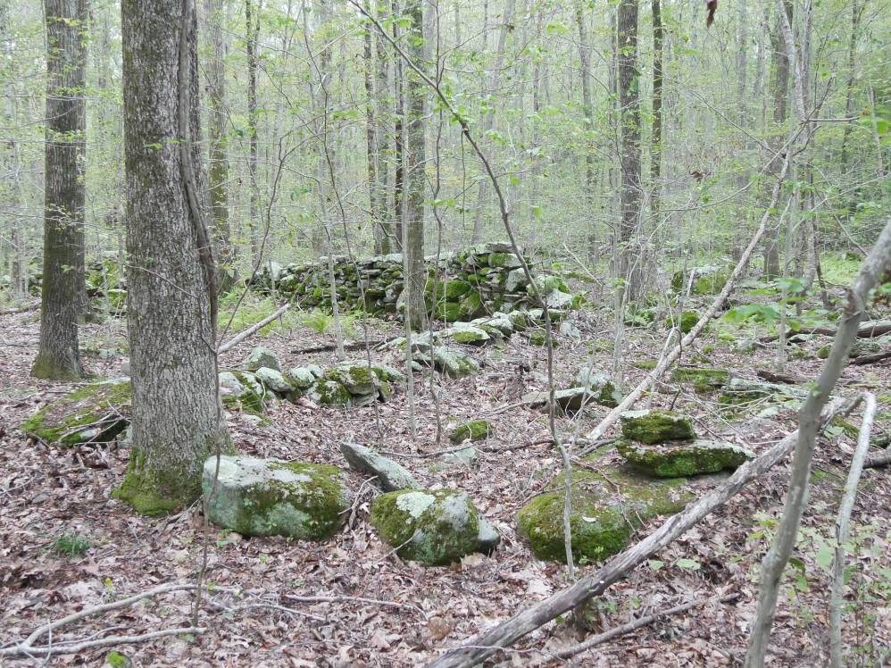

This is the southern half of the wall. It ends with a two stone rock stack at the entrance (arrow). Note the difference in height between the serpentine wall and the pasture wall in the background.

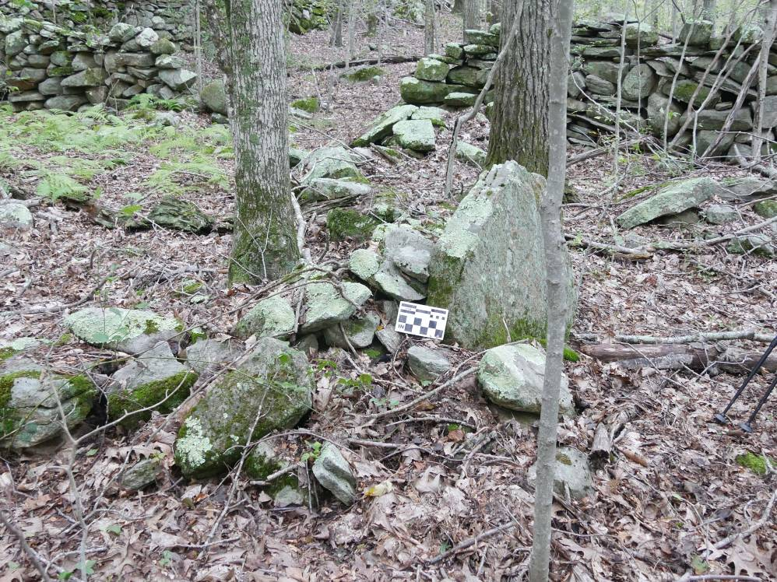
This is the northern section. The opening in the pasture wall in the background leads into a pasture. A standing stone was placed against the serpentine wall (arrow).
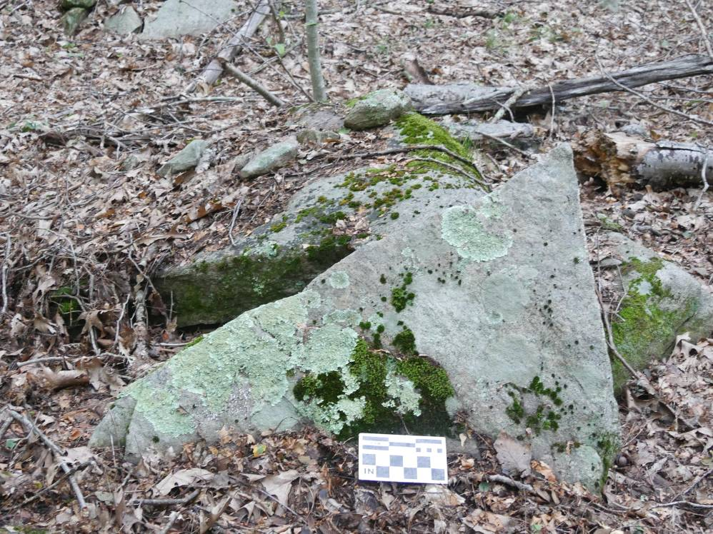

A short distance form the serpentine wall is this single layer on top of boulder cairn with triangular shaped standing stone leaning against it.
Overhanging Capstone Wall

Three sections of pasture wall on the farm (two in the West Side) were found that stood about 5 feet tall and were topped with capstones that projected over one side of the wall. According to James Robertson, a Scottish author (1813) “Even the double stone walls are rendered sufficient to turn sheep, … or by laying long stones across the top of the wall, without any sod, so as to project about eight inches over, on both sides; ...” These sheep pasture wall sections are consistant with both Joseph Brightman’s and Jonathan Foster’s probate inventories which listed a small flock of sheep. Only sections (not the entire length) have this type of construction. This may indicate an itinerant wall builder who repairs or builds sections of the walls.
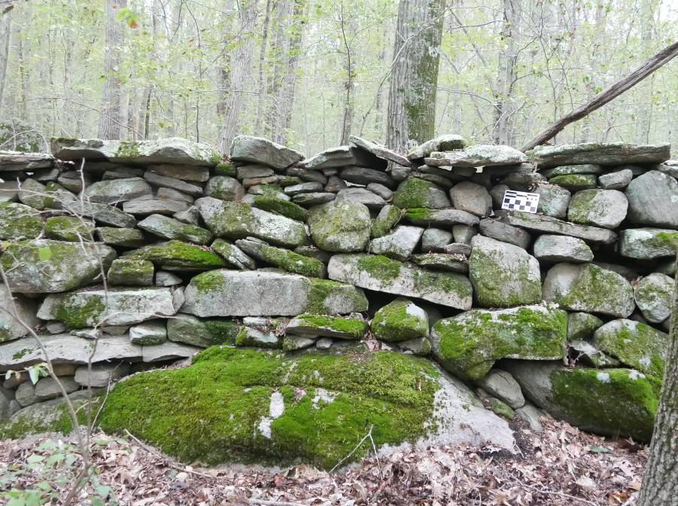

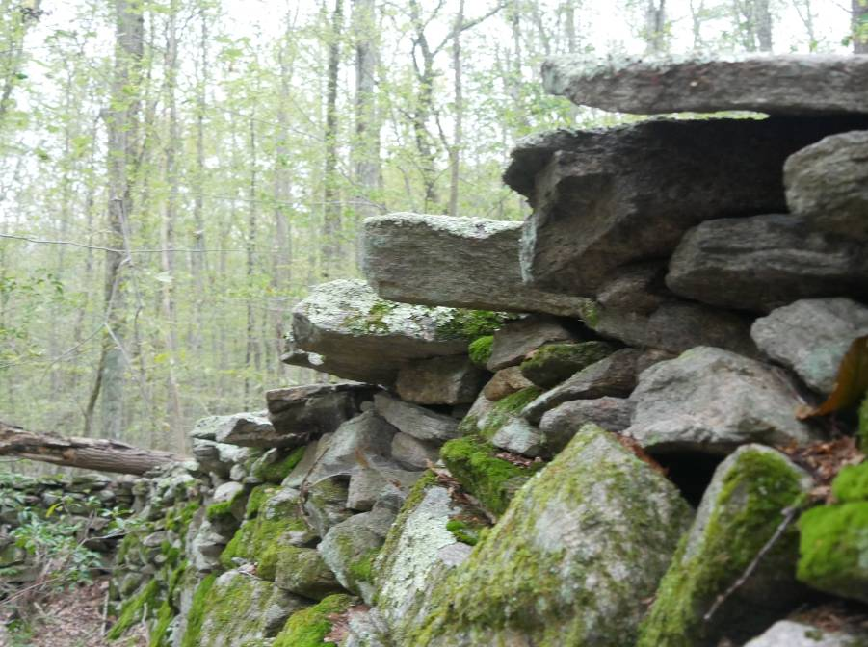

1868 et seq. Assessors Valuation of Taxable Property in the Town of Hopkinton [date]. a/k/a Hopkinton Tax Book. Westerly, RI.: G.B. & J.H. Utter, Printers. Available online on Google Books
Page 115, 1813. James Robertson, General View of the Agriculture of the County of Inverness [Scotland]. London: Printed for Sherwood, Neely, and Jones

